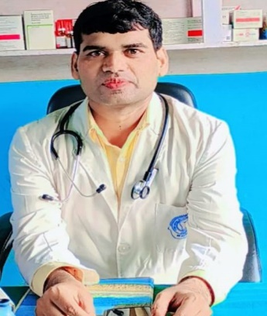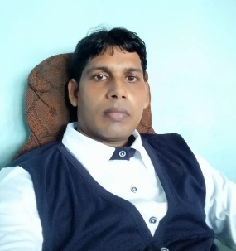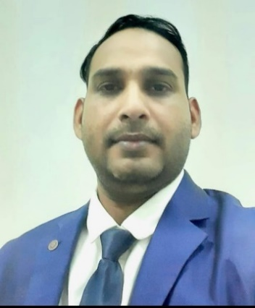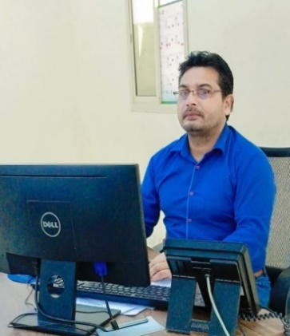

**DIRECTOR DIRECTOR HOD SCIENCE & MEDICAL HOD IT & COMPUTER**

**ER. MR. SIR AK. SIR DR. MJ. SIR IT. SIR**

**ER. MUKHTAR ANSARI MR. ASHFAK ANSARI DR. MUMTAJ ANSARI MR. IMTEYAT ANSARI**

**(HOD MATHS & EDUCATION)** **(HOD ENGLISH & GLOBAL PLACEMENT)** *(BDS,BLS,Medanta Gurugram/ (PGDCA & Computer Software Professional*

*(B.Tech, EE, MMMUT Gorakhpur, (M.A. English American Literature PIDS, GKP) From Govt. Polytechnic,Deoria.)*

*UPSEE-Rank -59 in 2012. B.ed.,DDU Global Manager,Chicago,USA*

*University,GKP,President of SSS,NGO ) PG in Marketing & Sales Management)*

**Message**

**“*I experienced during my practical life these four keywords (CKPP) which always stands out your skill outstanding. Follow these and you will be adorned with great success.”***

***C-Confidence K-Knowledge P- Patience P-Positivity***  ***-AK. SIR***

***“A good education is the foundation of a better future.”***

***-MR. SIR***

**About Us**

Greetings to all my dear readers and viewers!

We provide basic and competitional knowledge to the students. We have been a remarkable history in the field of education and career build up. We specialize to shape the future of the students on their hidden talents basis. No student should be categorize as fast or poor on the basis of their score card.

We search out the potential of the students and shape their career with desired training and coaching to develop their personality. Our core values have been given below :-

*\* We provide both online and offline abode for the students classes/admission/attendance etc.*

*\* We provide Distance Learning Programme(DLP) for the remote students or as per their accessibility.*

*\* We provide whole education solution like - *Boards (UP/CBSE/ICSE) *Preparation * University Courses * Vocational Courses *Training & Placement ( Both National & Global)*

*\*We provide time to time motivational speech and debate for the personality development.*

*\* Thousands of our alumni were adorned with degrees/certificates and lightening the world with their success story.*

***WE ARE READY TO SHAPE YOUR FUTURE NICELY***

***Join KNOWLEDGE KING EDU PVT LTD for career/degrees/certificates/knowledge/training/job placement and entire education solution relevant to your skill and calibre. We shape your career at all.***

***Thank you to all.***